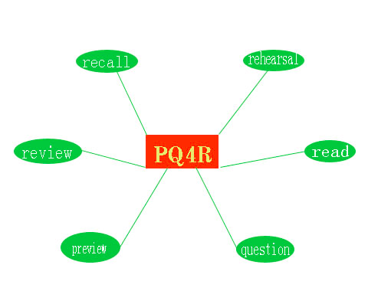

### **Stage 4: Reflect**

**Stage 5: Recite**

* The PQ4R Learning Method

#### Jake Mitchell

#### Period 7

**In Conclusion**

The PQ4R study method is supposed to help the student actually learn the information, so you can apply it on the test.

Review your work on a regular schedule. Attempting to cram all of the information in before the test will not help you as much as the PQ4R method.

After applying the information to something personal, repeat this information verbally. Gather a group of students and quiz each other on the discovered information.

Think about the information you have read, and find a way to relate it to something personal. Relate new information to personal experiences of the past to help remember.

## **Stage 6: Review**

**Stage 3**

**Read**

# **Stage 2**

# **Question**

**Stage 1**

**Preview**

**Summary**

The PQ4R study method was created for those who don’t know how to study properly for exams. It’s all about taking an active approach to learning. This study method is more effective than cramming information before the test. It actually allows the student to learn the information and not just remember definitions of words. This method can also help to reduce anxiety during tests.

Next, you need to actually read the material for the unit. As you read the information, answer the questions you had from the previous stage.

As you are previewing the unit, write down questions you have about the information. These questions consist of pieces of information you skim over that you aren’t sure of their meaning.

You start off the PQ4R with preview. Find the unit in the book you are going over and skim through it. You don’t have to actually read everything at this part of the study method.