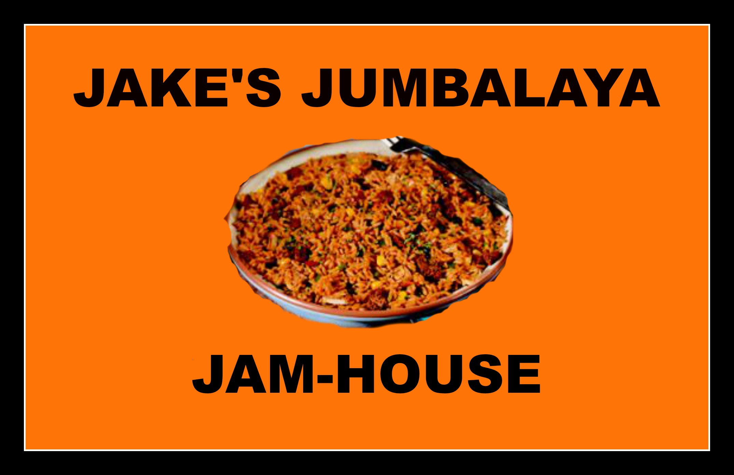

Social Media Posts
Social Media Platform | Post Idea | Action/Information Needed
Facebook | Send out thank you cards to those who attended the Grand Opening | Contacts of attendees
Twitter | Retweet, Favorite, and follow the account for a chance to win a $20 gift card | $20 gift card
Instagram | Post a photo from the Grand Opening | Upload a photo
Snapchat | Send a snap of Jumbalaya from the restaurant saying “Looks Delicious!” | Send photo
Facebook | Post asking people what they think of the restaurant | Post text
Twitter | Post asking people what they think of the restaurant | Tweet text
Instagram | Post a photo of our special shrimp Jumbalaya | Upload photo
Snapchat | Send a snap of the employees having a good time, showing we have fun here | Send photo
Facebook | Tell everyone about our special “buy a large bowl and get a small appetizer for free” deal | Post text
Twitter | Tell everyone about our special “buy a large bowl and get a small appetizer for free” deal | Tweet text

